# **Lab Manual 9**

**Subnetting**

**CLO 3**

**What Is Subnetting?**

Subnetting is the process of stealing bits from the HOST part of an IP address in order to divide the larger network into smaller sub-networks called subnets. After subnetting, we end up with NETWORK SUBNET HOST fields. We always reserve an IP address to identify the subnet and another one to identify the broadcast subnet address.

* **Address -** The unique number ID assigned to one host or interface in a network.
* **Subnet -** A portion of a network that shares a particular subnet address.
* **Subnet mask -** A 32-bit combination used to describe which portion of an address refers to the subnet and which part refers to the host.

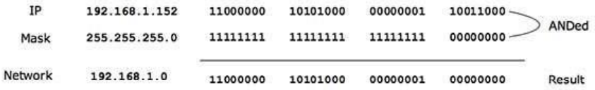

##### Understand Subnetting

Subnetting allows you to create multiple logical networks that exist within a single Class A, B, or C network. If you do not subnet, you are only able to use one network from your Class A, B, or C network, which is unrealistic.

Each data link on a network must have a unique network ID, with every node on that link being a member of the same network. If you break a major network (Class A, B, or C) into smaller subnetworks, it allows you to create a network of interconnecting subnetworks. Each data link on this network would then have a unique network/subnetwork ID. Any device, or gateway, that connects *n* networks/subnetworks has *n* distinct IP addresses, one for each network / subnetwork that it interconnects.

In order to subnet a network, extend the natural mask with some of the bits from the host ID portion of the address in order to create a subnetwork ID. For example, given a Class C network of 204.17.5.0 which has a natural mask of 255.255.255.0, you can create subnets in this manner:

204.17.5.0 - 11001100.00010001.00000101.00000000

255.255.255.224 - 11111111.11111111.11111111.11100000

|sub|

By extending the mask to be 255.255.255.224, you have taken three bits (indicated by "sub") from the original host portion of the address and used them to make subnets. With these three bits, it is possible to create eight subnets. With the remaining five host ID bits, each subnet can have up to 32 host addresses,

30 of which can actually be assigned to a device *since host ids of all zeros or all ones are not allowed* (it is very important to remember this). So, with this in mind, these subnets have been created.

|  |  |
| --- | --- |
| 204.17.5.0 255.255.255.224 | host address range 1 to 30 |
| 204.17.5.32 255.255.255.224 | host address range 33 to 62 |
| 204.17.5.64 255.255.255.224 | host address range 65 to 94 |
| 204.17.5.96 255.255.255.224 | host address range 97 to 126 |
| 204.17.5.128 255.255.255.224 | host address range 129 to 158 |
| 204.17.5.160 255.255.255.224 | host address range 161 to 190 |
| 204.17.5.192 255.255.255.224 | host address range 193 to 222 |
| 204.17.5.224 255.255.255.224 | host address range 225 to 254 |

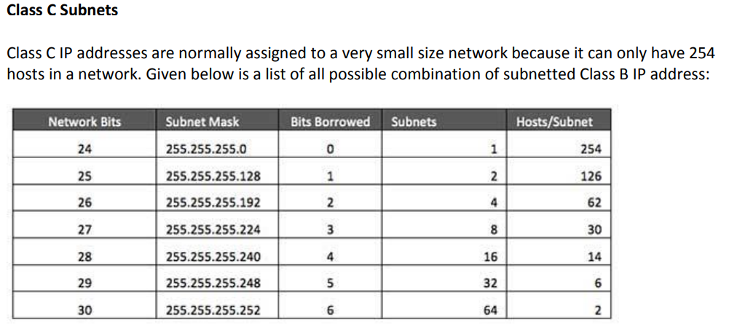

**IP Address Available 192.168.1.0**

**Q: If we have two remote site then judge that how many bits Subnetting and how many subnets available?**

1. What is your class Address?
2. How many networks bits?
3. How many remote brunches?
4. Default subnet Mask?
5. How many bits barrows?

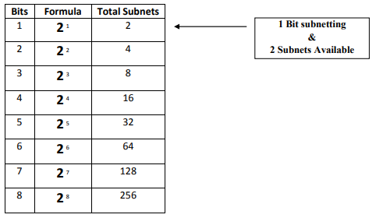

6) **Address and Range**

**Net ID** **192.168.1.0**

**Valid Range** 192.168.1.1 To 192.168.1.126

**Broad Cast ID** 192.168.1.127

**Net ID 192.168.1.128**

**Valid Range** 192.168.1.129 To 192.168.1.254

**Broad Cast ID** 192.168.1.255

Experiment: Apply **1-bit subnetting** on the following network toplogy.

